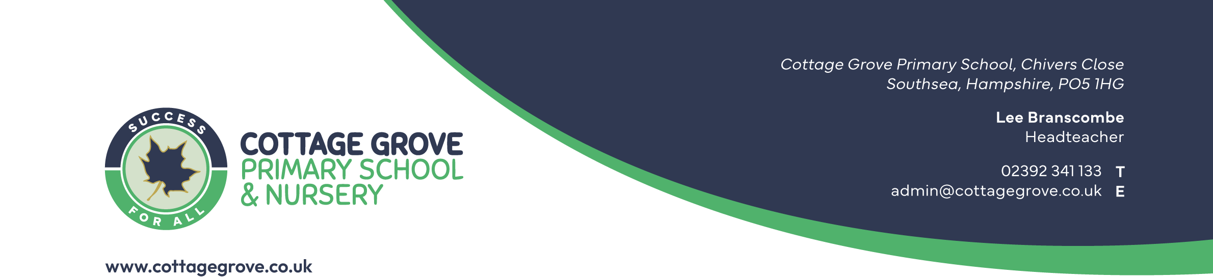
CG002

Accessibility Plan and Policy

Responsibility | Lee Branscombe (Headteacher)
Date Reviewed | July 2026
Review Cycle | 3 Years
GOVERNORS
Governor Approval Meeting
Governor Approval Date

Contents
Introduction 3
Definition of Disability 3
The School Curriculum 3
The Physical Environment 3
Delivery of materials in other formats 4
Audit School Resources 4
Change Log 5

Introduction
At Cottage Grove we provide for the additional needs of disabled pupils who have special
educational needs (SEND). We are an inclusive school and plan to increase over time the
accessibility and opportunities at our school for disableed pupils, in line with the Disability
Discrimination Act 1995 (DDA).

Definition of Disability
A person has a disability if he or she has a physical or mental impairment that has a substantial and long-term adverse effect on his or her ability to carry out normal day-to- day activities.
We are required to plan for:
- increasing access for disabled pupils to the school curriculum.
- improving access to the physical environment of schools.
- improving the delivery of written information to disabled pupils.

The School Curriculum
In this section we outline how we deliver the curriculum to disabled pupils. Where appropriate the teachers and teaching assistants receive the necessary training to teach and support the needs of our disabled pupils. This is often in-house training by the Inclusion Manager with outside agency support.
We have high expectations of all pupils. All lessons are differentiated to meet the needs of the pupils. In order to remove barriers to learning and participation there may be the need for increased specialisation and the curriculum may be adapted through use of specialist equipment. Through IEPs/ PPP/ risk assessments the needs of the child are recognised with appropriate targets set, as is recognition of additional time required by some disabled pupils to use equipment in practical work and access to computer technology appropriate for students with disabilities.
All pupils are encouraged to take part in music, drama and physical activities.

The Physical Environment
Our school does not have any stairs and therefore all our classrooms are on ground level.
Currently some classrooms have a step to the playground. In the event of a child not being able to access these rooms at the appropriate time the organisation of the classrooms would be changed in order to meet the needs of the pupils, or remedial work will be carried out to allow access for children with mobility issues. Our playground and sporting facilities, assembly and dining halls are on ground level allowing access for all.
Where necessary the furniture and equipment selected will be adjusted and located appropriately for the needs of the pupils.
Cottage Grove has adapted the environment for better access by providing a level entrance to the main school entrance, installing disabled and ambulant toilets and ensuring the Reception desk in the front office is welcoming for able bodied and disabled people. A hearing loop is installed.

Delivery of materials in other formats
For visually impaired pupils we can enlarge print, use specialist equipment i.e. magnifiers and mirror screens to laptops to support their learning. We also work in conjunction with the Visual Impaired Team at the Local Authority.
Through discussion with the outside agencies we will adapt to the needs of the pupils, where possible i.e. SATs ordering materials suitable to give the child independence.
EHCP for SEND pupils, which include additional adult support, are adhered to and our LSAs can be trained to facilitate learning by various methods which includes differentiating work further, adapting written materials and using specialist equipment.

Audit School Resources
When school is notified of a disabled child joining Cottage Grove we will carry out an audit of the site and curriculum to ensure we do our best to meet the specialist requirements. This may include:
- Training for teachers and support staff on differentiating the curriculum to more fully meet the requirements of disabled children’s needs with regards to accessing the curriculum
- Accessibility of resources - this might involve planned use of capital for minor alterations. If larger sums of capital are required Cottage Grove would discuss with the Trust and see if any SCA funding could be used
- The school makes itself aware of, and uses, the support services available.

Change Log

Version | Key Changes
CG002 | - Changed person responsible to Lee Branscombe (Headteacher)  - Added strategies for supporting children with visual impairments  - Changed funding requests from the LA to The Gateway Trust

