VALUES AND ETHOS STATEMENT

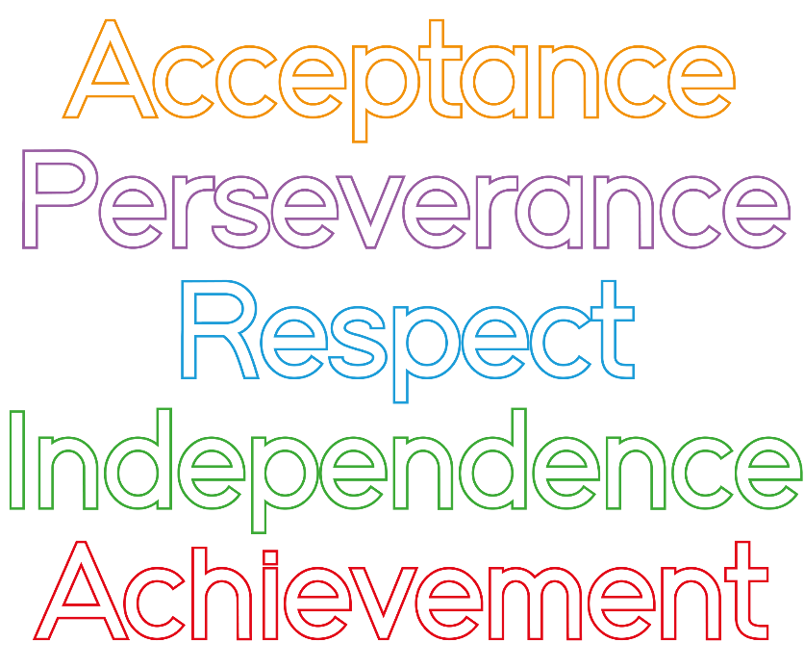
Our Values
At Cottage Grove we believe that acceptance; perseverance; respect; independence and achievement are important principles to apply to our lives, both inside and outside of school. In light of this, we have made these values a key part of our school's culture in the following ways:
Acceptance - We are thoughtful of those around us and learn and play in harmony. We understand and accept that we are all different and we show tolerance to others.
Perseverance - We keep trying with our learning and our friendships, even when things get really hard. We challenge ourselves and those around us to do better and achieve our dreams in the belief that everything is possible.
Respect - We respect other people’s views and are always polite. We care for each other and our environment.
Independence - We take responsibility for our own learning and behaviour. We find our own solutions to help us solve our problems.
Achievement - We have high aspirations, always do our best and help others to do their best. We like to celebrate our success.

